App.js:
import React from 'react';

function App() {
return (
<h1>Welcome to the first session of React</h1>
);
}

export default App;

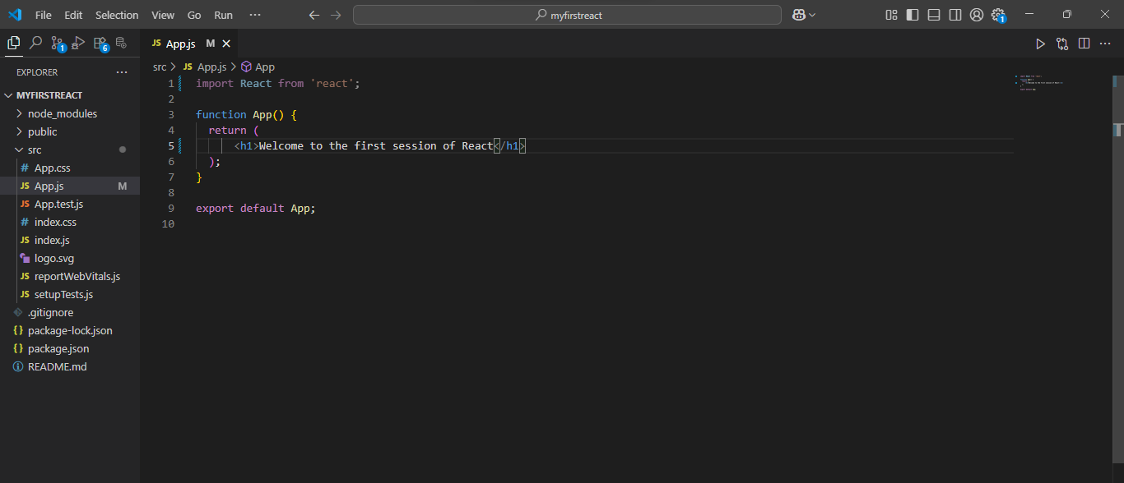
Output:
